note: this working document has not been endorsed by the European Commission but has been prepared by the Commission services as basis for a discussion with members of the Consultation Forum about the possible inclusion of a repairability score for household tumble dryers as envisaged in accordance with Article 7(2) of the revised energy labelling regulation for tumble dryers. The document outlines possible amendments to that delegated act to integrate such a score in the new label.

ANNEX
- In Annex I, the following definitions are added:
‘(26) ‘spare part’ means a separate part that can replace a part with the same or similar function in a household tumble dryer. The functionality of the household tumble dryer is restored or upgraded when the part is replaced by a spare part. Fasteners are not parts;
(27) ‘disassembly’ means a process whereby a product is separated into its parts and/or components in such a way that it could subsequently be reassembled and made operational;
(28) ‘fastener’ means a hardware device or substance that mechanically, magnetically or by other means connects or fixes two or more objects, parts or pieces. A hardware device which in addition serves an electrical function shall also be considered a fastener;
(29) ‘reusable fastener’ means a fastener that can be completely reused in the reassembly for the same purpose and that does no damage either to the product or to the fastener itself during the disassembly or reassembly process in a way that makes their multiple reuse impossible;
(30) ‘removable fastener’ means a fastener that is not a reusable fastener, but whose removal does not damage the product, or leave residue, which precludes reassembly;
(31) ‘resupplied fastener’ means a removable fastener that is supplied at no additional cost with the spare part which it is intended to connect or fix; adhesives shall be considered resupplied fasteners if they are supplied with the spare part in a quantity that is sufficient for the reassembly, at no additional cost;
(32) ‘step’ means an operation that finishes with the removal of a part (or bundle) or with a change of tool; any placement of a part away from its initial location, even if that entails partial disconnection or unplugging, shall also be considered as removal;
(33) 'basic tools' means a screwdriver for slotted heads, a screwdriver for cross recess screws, a screwdriver for hexalobular recess heads, a hexagon socket key, a combination wrench, combination pliers, combination pliers for wire stripping and terminal crimping, half round nose pliers, diagonal cutters, multigrip pliers, locking pliers, a prying lever, tweezers, magnifying glass, a spudger and a pick;
(34) ‘commercially available tool’ means a tool that is available for purchase by the general public and is neither a basic tool nor a proprietary tool;
(35) ‘proprietary tool’ means a tool that is not available for purchase by the general public or for which any applicable patents are not available to licence under fair, reasonable and non-discriminatory terms:
- In Annex II, the following section is added:
‘4. REPAIRABILITY CLASS
The repairability class of a household tumble dryer shall be determined on the basis of the repairability index as set out in Table 4. The repairability index shall be determined in accordance with Annex IV, point 5.
Table 4
Reparability classes of household tumble dryers
Reparability class | Reparability index (R)
A (most repairable) | R > 9,0
B | 7,0 ≤ R ≤ 9,0
C | 5,0 ≤ R < 7,0
D | 3,0 ≤ R < 5,0
E (least repairable) | R < 3,0
’;
- Annex III is amended as follows:
      - Figure 1 is replaced by the following: (adding an A-to-E repairability icon in line with the condensation efficiency and noise icons)
‘
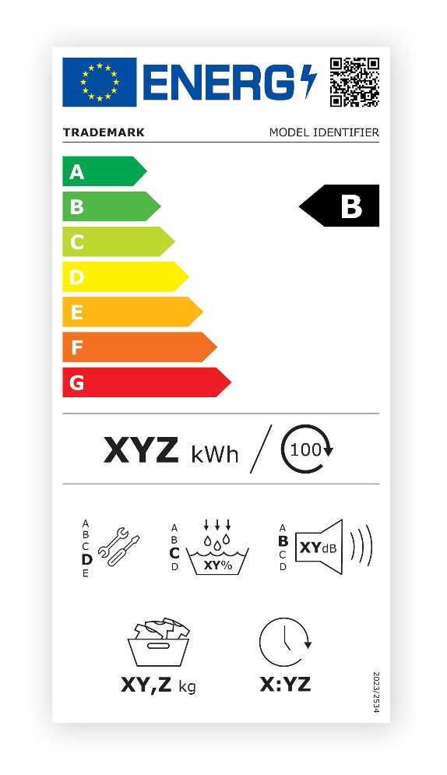
’;
      - Figure 2 is replaced by the following: (adding an A-to-E repairability icon in line with the condensation efficiency and noise icons)
‘
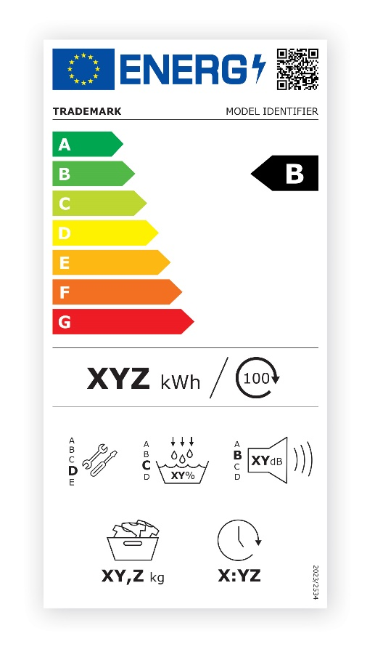
’;
      - Figure 3 is replaced by the following: (adding an A-to-E repairability icon in line with the noise icon)
‘
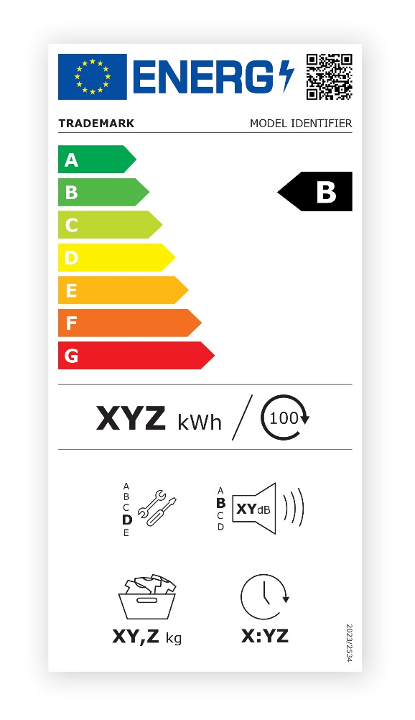
’;
      - Figure 4 is replaced by the following: (adding an A-to-E repairability icon in line with the noise icon)
‘
’;
- In Annex IV, the following section is added:
‘

METHOD FOR THE CALCULATION OF THE REPAIRABILITY INDEX OF HOUSEHOLD TUMBLE DRYERS
The reparability index is an aggregated and normalised score, as a calculated value derived from five scoring parameters where:
- S_{DD} is the “Disassembly Depth” score.
- S_{F} is the “Fasteners (type)” score.
- S_{T} is the “Tools (type)” score.
- S_{RI} is the “Repair Information” score.
- S_{DS} is the “Detachability of the side panels” score.
The Repairability Index (R) shall be calculated as follows:
$$R=0,225×S_{DD}+0,225×S_{F}+0,225×S_{T}+0,100×S_{RI}+0,225×S_{DS}$$
The “Disassembly Depth” (S_{DD}), “Fasteners (type)” (S_{F}) and “Tools (type)” (S_{T}) scores are based on the aggregation of the following priority part level scores:
- WP is the water pump.
- B is the drum bearing.
- DB is the drum belt.
- D is the door.
- M is the motor.
- MB is the main electronic board.
- F is the fan.
- MC is the motor capacitor.
If any of the priority parts listed above is present in a product more than once, only the one which delivers the lowest score shall be considered in the calculation of the “Disassembly Depth” (S_{DD}), “Fasteners (type)” (S_{F}) and “Tools (type)” (S_{T}) scores. If a priority part is not present in the product, the highest point level for each score shall be considered for this part.
The “Disassembly Depth” (S_{DD}) score shall be calculated as follows:
$$S_{DD}={DD}_{WP}×0, 14+{DD}_{B}×0,09+{DD}_{DB}×0,25+{DD}_{D}×0,08+{DD}_{M}×0,05+{DD}_{MB}×0,28+{DD}_{F}×0,05+{DD}_{MC}×0,06$$
Disassembly Depth (DD) assessment at part level
The Disassembly Depth score (DD_{i}) for each priority part (DD_{WP}, DD_{B}, DD_{DB}, DD_{D}, DD_{M,} DD_{MB,} DD_{F}, DD_{MC}) shall be set according to Table 5, on the basis of the percentage of steps required to remove the priority part from the product with respect to the mean number of disassembly steps (MDS) for that priority part as laid down in Table 6, without damaging the product. The counting of the steps for each part starts from the product fully assembled.
Table 5
Disassembly Depth score
disassembly steps (as percentage of MDS) | DD_{i}
DD ≤ 70% MDS  70% MDS< DD ≤ 90% MDS  90% MDS < DD ≤ 110% MDS  110% MDS < DD ≤ 130% MDS  DD > 130% MDS | 10  7  4  1  0
Table 6
Mean number of disassembly steps
Priority part | Mean number of disassembly steps (MDS)
Water pump  Drum bearing  Drum belt  Door  Motor  Main board  Fan  Motor capacitor | 16,1  18,9  40,9  3  49,4  13,7  7,7  24,9
For the calculation of disassembly depth, the following rules shall apply:
- the disassembly depth count is completed when the target part is separated and individually accessible;
- where multiple tools need to be used simultaneously, the use of each tool counts as a separate step;
- operations related to cleaning, removing traces or heating are counted as steps;
- the disassembly depth shall be calculated on the basis of the repair and maintenance information, and of the description of the disassembly steps for each priority part given in the technical documentation;
- where remote notification or authorisation of serial numbers is necessary for the full functionality of the spare part and the device, each of these actions is counted as five additional disassembly steps.
The Fasteners type score (S_{F}) is calculated as follows:
$$S_{F}=F_{WP}×0, 14+F_{B}×0,09+F_{DB}×0,25+F_{D}×0,08+F_{M}×0,05+F_{MB}×0,28+F_{F}×0,05+F_{MC}×0,06$$
Fasteners (type) (F) assessment at part level
The “Fasteners (type)” scores (F_{i}) for each priority part i (F_{WP}, F_{B}, F_{DB}, F_{D}, F_{M,} F_{MB,} F_{F}, F_{MC}) are assigned according to the level of removability and reusability of the fasteners used in the device assembly. Points are assigned according to Table 7.
Table 7
Fasteners type score
Fastener type | F_{i}
Reusable  Resupplied  Removable | 10  5  0
The assessment of the type of fasteners is based on the disassembly process to remove the specific priority part, starting from the previous priority part already removed in the disassembly sequence.
In case different types of fasteners are encountered in the disassembly of a priority part, the lowest score shall be considered.
The F_{i} scores shall be calculated on the basis of the repair and maintenance information, and of the description of the fasteners for each priority part given in the technical documentation.
The Tools type score (S_{T}) shall be calculated as follows:
$$S_{T}=T_{WP}×0, 14+T_{B}×0,09+T_{DB}×0,25+T_{D}×0,08+T_{M}×0,05+T_{MB}×0,28+T_{F}×0,05+T_{MC}×0,06$$
Tools type (T) assessment at part level
The Tools type scores (T_{i}) for each priority part i (T_{WP}, T_{B}, T_{DB}, T_{D}, T_{M}, T_{MB}, T_{F}, T_{MC}) are assigned according to the complexity and availability of the tools needed for its replacement. Points are assigned according to Table 8.
Table 8
Tool type score
Use of tools | T_{i}
Repair possible without tools, with commercially available tools or with tools supplied with the spare part or with the household tumble dryer  Repair only possible with tools that are exclusively available to a professional repairer  Repair only possible with tools that are exclusively available to authorised service partners | 10  6  2
The assessment of the type of tools is based on the disassembly process to remove the specific priority part, starting from the previous priority part already removed in the disassembly sequence.
Where different types of tools are needed for the disassembly of a priority part, the lowest score shall be considered.
The T_{i} scores shall be calculated on the basis of the repair and maintenance information, and of the description of the tools for each priority part given in the technical documentation.
Repair Information (RI) assessment at product level
The Repair Information score (S_{RI}) shall be calculated at product level according to Table 9.
Table 9
Repair information score
Use of tools | S_{RI}
Availability of repair information at no cost for professional repairers  Availability of repair information with a reasonable and proportionate fee for professional repairers | 10  5
A fee shall be considered reasonable if it does not discourage access to repair information by failing to take into account the extent to which the professional repairer uses the information.
Detachability of the side panels (DS) assessment at product level
The detachability of the side panels score (S_{DS}) shall be calculated at product level according to Table 10.
Table 10
Detachability of the side panels
Number of sides which panels can be removed independently of all other side panels | Score
Side panels of all four sides can be removed independently of all other sides  Side panels of three sides can be removed independently of all other sides  Side panels of two sides can be removed independently of all other sides  Side panel of one side can be removed independently of all other sides | 10  7  4  1
’;
- in Annex V, Table 4 is replaced by the following:
‘
Table 11
Content, order and format of the product information sheet
Supplier’s name or trade mark (ª), (^{c}):
Supplier’s address (ª), (^{c}):
Model identifier(ª):
Technology of tumble dryer |  |  | [electric air-vented, electric condenser, gas-fired]
General product parameters:
Parameter |  | Value |  |  | Parameter | Value
Rated capacity(^{b}) (kg) |  | x,x |  |  | Dimensions(ª), (^{c}) in cm | Height | x
 |  |  |  |  |  | Width | x
 |  |  |  |  |  | Depth | x
Energy Efficiency Index (EEI) (^{b}) |  | x,x |  |  | Energy efficiency class (^{b}) | [A/B/C/D/E/F/G] (^{d})
Condensation efficiency (%) (^{b})  (if applicable) |  | xx |  |  | Condensation efficiency class (if applicable)^{(b)} | [A/B/C/D] (^{d})
Weighted energy consumption in kWh per drying cycle (^{h}). Actual energy consumption will depend on how the appliance is used. |  | x,xx
Programme duration (^{b}) (hours:minutes) |  | Rated capacity |  | x:xx | Type | [built-in/free-standing]
 |  | Half |  | x:xx
Acoustic airborne noise emission (^{b}) (dB(A) re 1 pW) |  | x |  |  | Acoustic airborne noise emission class^{(b)} | [A/B/C/D] (^{d})
Off-mode (if applicable) (W) |  | x,xx |  |  | Standby mode (if applicable) (W) | x,xx
Delay start (W) (if applicable) |  | x,xx |  |  | Networked standby (W) (if applicable) | x,xx
For household tumble dryers equipped with a heat pump, the chemical name or the accepted industry designation of the refrigerant gas used, without prejudice to Regulation (EU) No 517/2014 on fluorinated greenhouse gases (¹) (ª) (^{c}).
 | Repairability information:
 | Repairability Class (based on the index below) |  |  |  |  | [A/B/C/D/E]^{b}
 | Repairability Index (^{b}) |  |  |  |  | x,xx/10
 | Disassembly Depth (S_{DD}) score (^{b}) |  |  |  |  | x,xx/10
 | Fasteners type score (S_{F}) (^{b}) |  |  |  |  | x,xx/10
 | Tools type score (S_{T}) (^{b}) |  |  |  |  | x,xx/10
 | Repair information score (S_{RI}) (^{b}) |  |  |  |  | x,xx/10
 | Detachability of the side panels score (S_{DS}) (^{b}) |  |  |  |  | x,xx/10
 | Weblink to information on spare parts availability for professional repairers and end users (ª) (^{c}) (^{e}) |  |  |  |  | https://xxx
Weblink to repair instructions for end-users (ª) (^{c}) (^{f}) |  |  |  |  |  | https://xxx
Weblink to indicative pre-tax prices (ª) (^{c}) (^{g}) |  |  |  |  |  | https://xxx
Minimum duration of the guarantee offered by the supplier (ª) (^{c})
Additional information(ª) (^{c}):
Link to the supplier’s website, where the information in point 6 of Annex II to Commission Regulation (EU) 2023/2533 (^{c}) (²) is found:
’;
- in Annex VI, point 1(d) is replaced by the following:
‘(d) the details and the results of calculations performed in accordance with Annex IV, with the exception of point 1(g) of that Annex’;
- in Annex IX, the first subparagraph in point 4(b)(iii) is replaced by the following:
‘(iii) the determined values, that is to say the values of the relevant parameters as measured in testing and the values calculated from these measurements comply with:’.

Commission Delegated Regulation (EU) 2023/2534 of 13 July 2023 supplementing Regulation (EU) 2017/1369 of the European Parliament and of the Council with regard to energy labelling of household tumble dryers and repealing Commission Delegated Regulation (EU) No 392/2012 https://eur-lex.europa.eu/eli/reg_del/2023/2534/oj

