# Explanatory Memorandum to

**COMMISSION REGULATION (EU) No ……/……**

**of** XXX

**Implementing Directive 2009/125/EC of the European Parliament and of the Council with regard to ecodesign requirements for professional refrigerated storage cabinets, scientific and healthcare refrigerated storage cabinets, blast cabinets, condensing units and process chillers,** **repealing Regulation (EC) 2015/1095**

**AND**

**COMMISSION REGULATION (EU) No ……/……**

**of** XXX

**Supplementing Regulation (EU) 2017/1369 of the European Parliament and of the Council with regard to the energy labelling of professional refrigerated storage cabinets, scientific and healthcare refrigerated storage cabinets and condensing units, repealing Regulation (EC) 2015/1094**

*This draft has not been adopted or endorsed by the European Commission. Any view expressed are the preliminary views of the Commission services and may not in any circumstances be regarding as stating an official position of the Commission. The information transmitted is intended only for the Member State or entity to which it is addressed for discussions and may contain confidential and/or privileged material.* ***Dates and timelines mentioned in this draft may be subject to change.***

1. CONTEXT OF THE PROPOSAL

## Introduction and general objectives of the proposal

This explanatory memorandum aims to give further background to the proposal for a review by the European Commission of Ecodesign Commission Regulation (EU) 2015/1095[1] on the ecodesign of professional refrigeration products and Commission Delegated Regulation (EU) 2015/1094[2] energy labelling of professional refrigerated storage cabinets, following the revision clauses in both regulations.

The EU has longstanding objectives to increase energy efficiency and to reduce its greenhouse gas emissions. These go along with other objectives to reduce its environmental impacts. In December 2019, the Commission presented the European Green Deal[3] to strengthen these objectives and as the cornerstone of its strategy to fulfil the United Nation’s 2030 Agenda for Sustainable Development[4]. In September 2020, it presented a Climate Target Plan (CTP) for 2030[5], showing the need for a higher contribution of energy efficiency and renewable energy to achieve a net 55 % GHG emission reduction most cost-effectively, in line with the Paris Agreement. The Commission followed this by proposing the “Fit for 55” package[6] of legislative proposals aiming to achieve the necessary cut in GHG emissions.

One pillar of the CTP and subsequently the ‘Fit for 55’ package is energy efficiency. In this context, the ecodesign and energy labelling rules for products arise as important instruments to realise EU’s energy and decarbonisation objectives.

Another pillar of the European Green Deal is a more circular economy. The new Circular Economy Action Plan[7] sets out steps to work towards this. It aims to reduce product environmental impacts for example through promoting longer product lives, greater resource efficiency and enhancing recycling and recycled content. The Ecodesign and Energy Labelling Working Plan 2022-2024[8] incorporated the review of professional refrigeration appliances and, as in the previous plan, identified ecodesign measures’ potential to contribute to circular economy objectives.

Reducing energy use and promoting the circular economy are also important for reducing the EU’s energy import dependence and improving energy security, aspects that are particularly relevant in the current context of continuous increase of energy prices and recent geopolitical events. On 18 May 2022, the Commission published its “REPowerEU Plan” Communication[9] aimed at rapidly reducing EU dependence on Russian fossil fuels.

The Ecodesign Directive[10] aims to address market barriers to the uptake of more energy efficient and sustainable products by setting performance requirements to remove the worst performing products from the EU’s internal market. Being set at EU level, they have mitigated the risk of industry facing multiple, different national rules. The energy assessments aim to ensure that the minimum requirements are set at the level of Least Life cycle Consumer Cost. The 2017 Energy labelling regulation[11] gives rules on how to inform consumers with the aim of encouraging them to purchase products that have a better energy performance. This has helped consumers to reduce their energy bills by easily identifying and comparing more energy efficient appliances. Nearly 80 % of the EU public recognise the label and say it has influenced their purchase decision[12], and EU energy labels are known, used or replicated outside the EU[13].

## Product scope

Commission Regulation (EU) 2015/1095 sets minimum energy efficiency and information ecodesign requirements for the placing of the market of the professional refrigeration products. These products are:

* refrigerated storage cabinets, including full ecodesign and energy labelling requirements for vertical (figure 1) and undercounter cabinets (figure 3) as well as information requirements for blast cabinets;
* medium temperature and low temperature (MT & LT) remote condensing units (figure 5);
* medium temperature and low temperature (MT & LT) process chillers (figure 6).

Commission Delegated Regulation (EU) 2015/1094 (energy labelling) also sets energy labelling requirements for the placing of the market of professional refrigerated storage cabinets.

Professional refrigerated storage cabinets excluded from the scope are — amongst others — roll in and roll-through cabinets (used with trolleys, figure 2), saladettes (figure 4), walk-in cold rooms (WICR), etc. Blast cabinets (cabinets with quick chill/freeze capacity) are excluded from the scope of the energy labelling regulation, but some ecodesign information requirements apply.

Remote condensing units exist in small sizes for cooling/freezing of single cabinets (as figure 5) in the hospitality and catering sector or in larger sizes for e.g. several refrigeration ‘direct sales’ appliances in a supermarket.

The industrial process chillers (figure 6) are used predominantly in the food industry and warehousing. They exist for medium temperature cooling (MT, −8 °C) or low temperature freezing (LT, −25 °C). The chillers can either be water-cooled or air-cooled. High-temperature (HT, +7 °C) chillers, e.g. used for air conditioning of data centres, are excluded from the scope here, but regulated elsewhere[14].

Blast cabinets (not shown) are insulated refrigerating appliances primarily intended to rapidly cool hot foodstuffs to below 10 °C in the case of chilling and below – 18 °C in the case of freezing, in order to conserve said foodstuffs.

The professional refrigerating appliances are not the only refrigeration appliances being regulated through Ecodesign Directive 2009/125/EC and Energy Labelling Regulation (EU) 2017/1369. Figure 7 gives an overview of the various ecodesign and labelling regulations in refrigerated appliances.

The review clauses of the Regulations stipulate that the Commission shall review the two Regulations in the light of technological progress no later than five years after their entry into force. The review study is meant to inform the Commission and, if necessary, supply the necessary elements for a revision of the two Regulations.

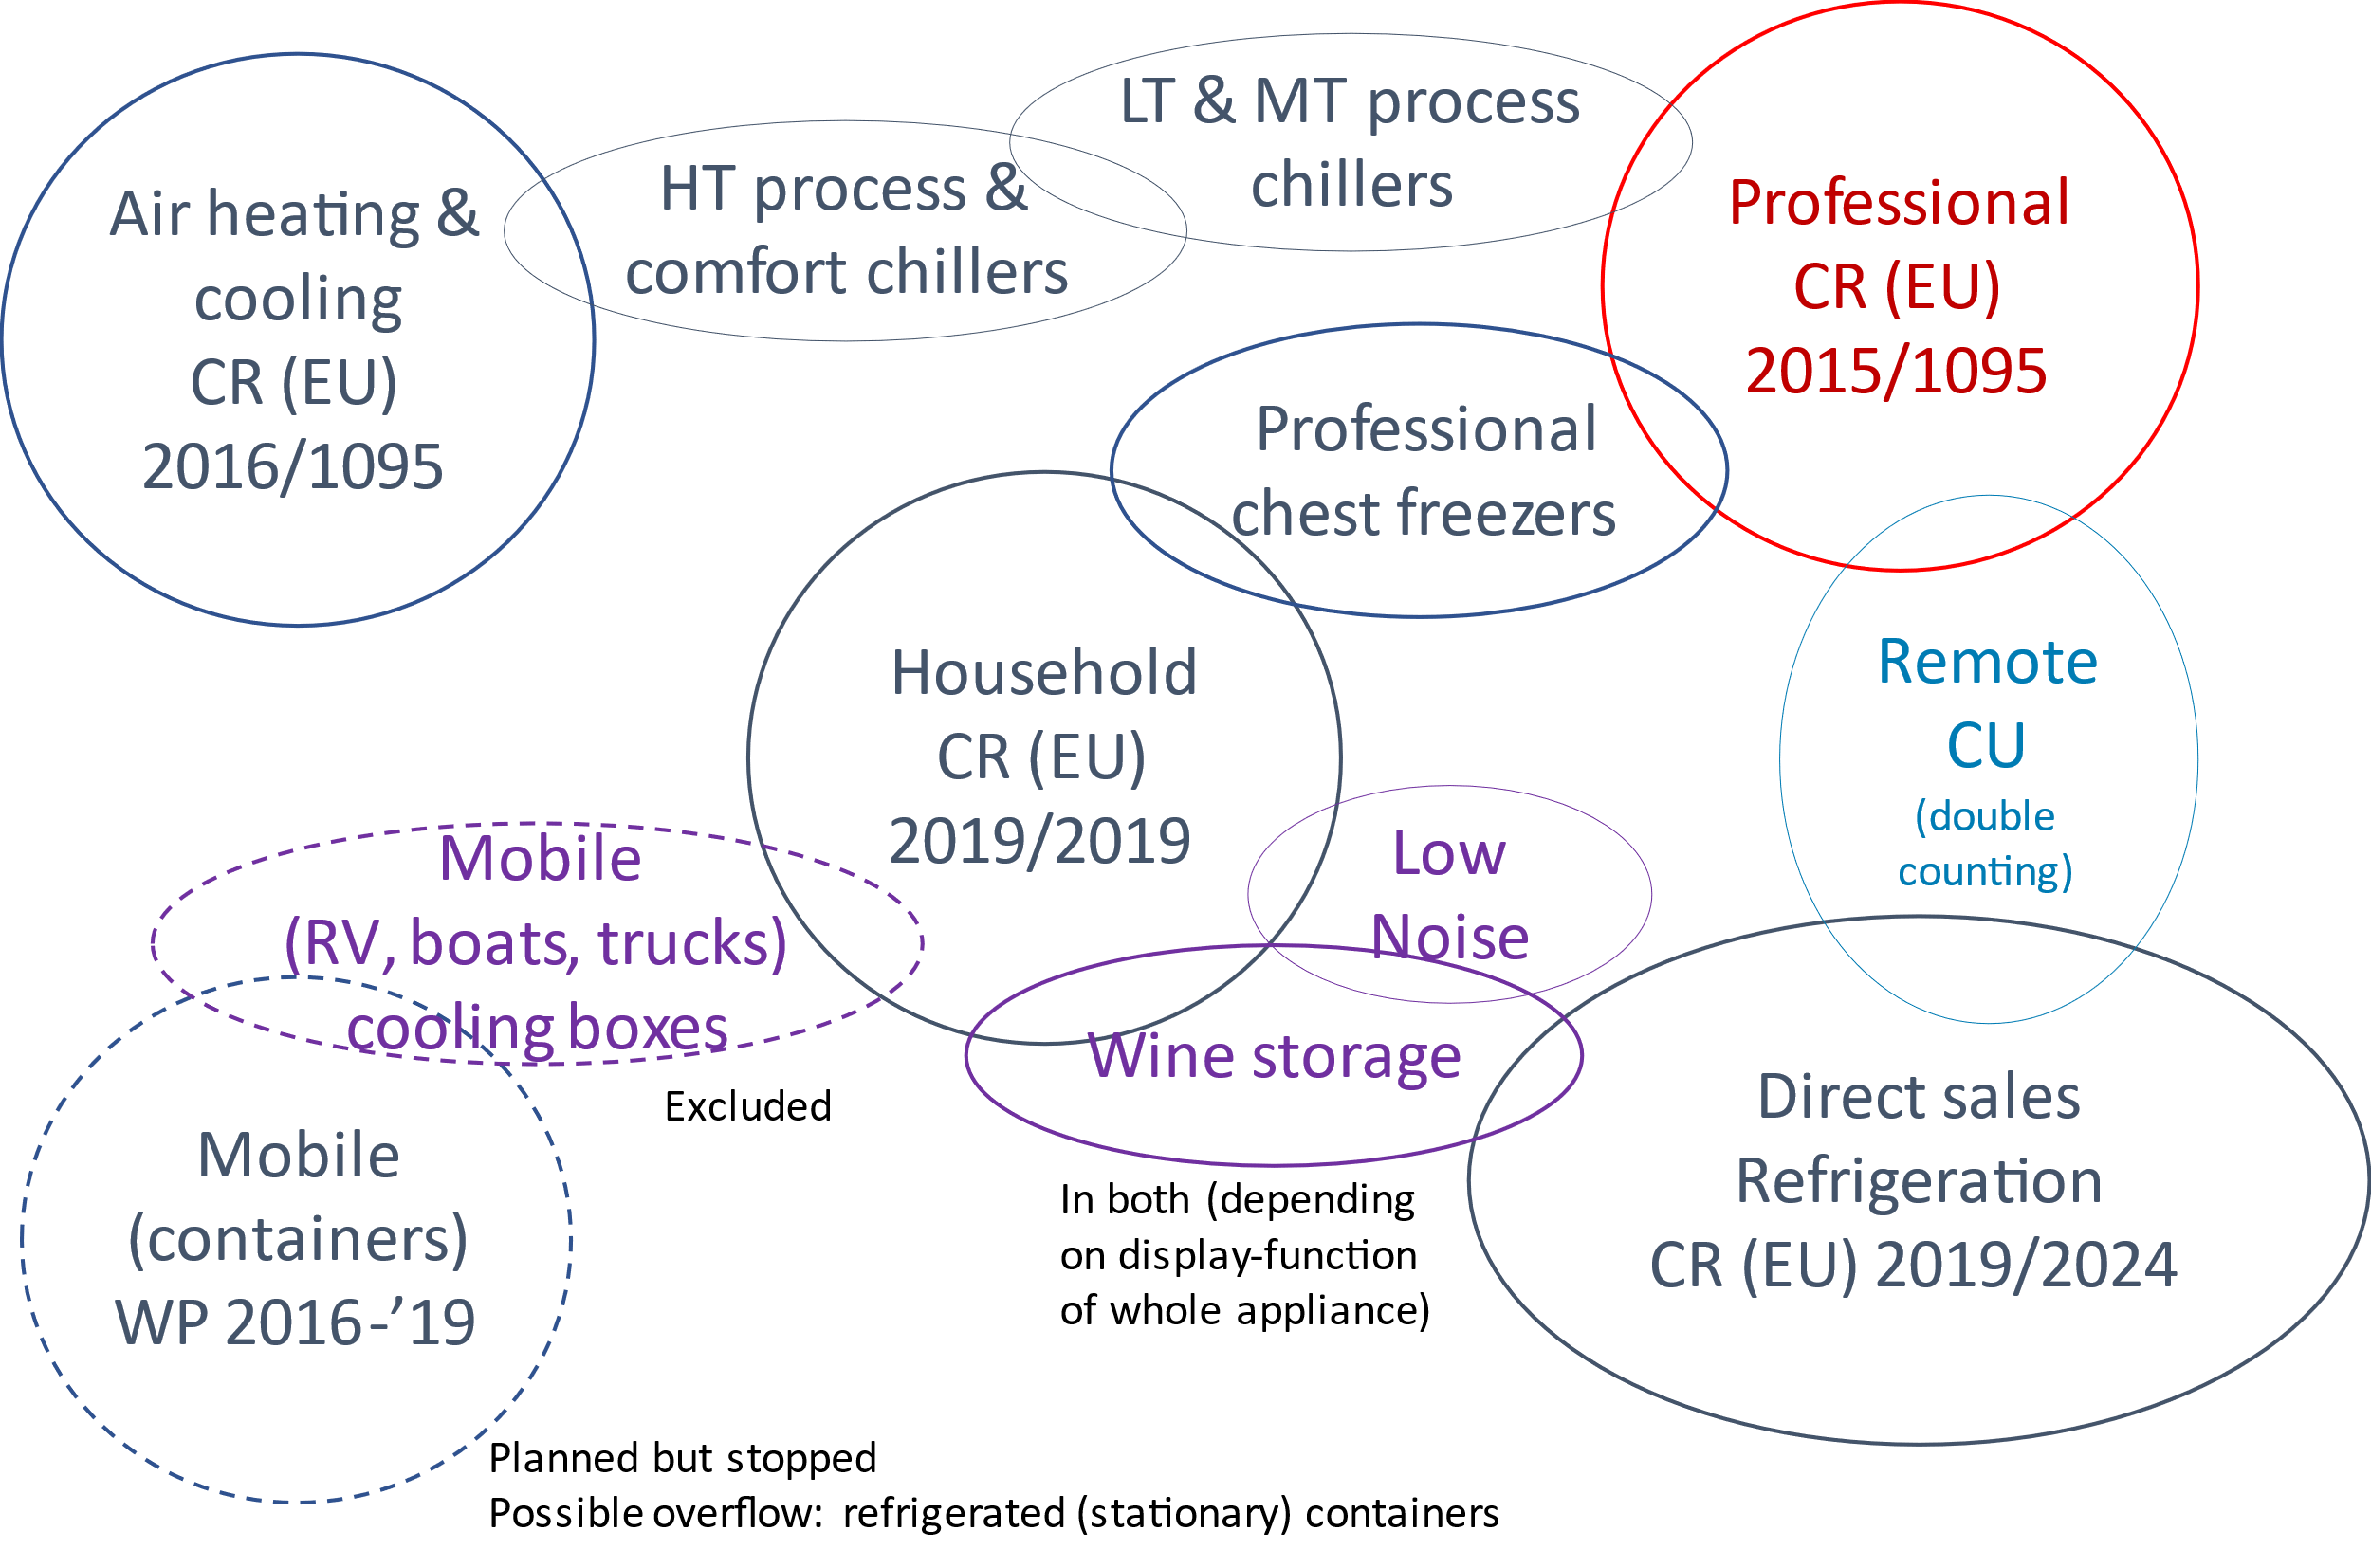

*Figure 7: EU Ecodesign regulations of refrigerating appliances.*

## Key impacts

Electricity consumption (EU27, 2020) of products currently in scope is 80.5 TWh/a (condensing units corrected for double counting, e.g. with commercial refrigeration), of which professional refrigerated storage cabinets consume 8.2 TWh/a, condensing units 25.3 TWh/a and process chillers 46.9 TWh/a. Without new measures, at a growth rate of 2 % per year and an efficiency improvement of 0.5 % per year this could arrive at a consumption of about 100 TWh/a in 2030. Under current circumstances this is a number with considerable uncertainty[15]. An electricity consumption of 100 TWh/a is slightly less than the annual electricity consumption of a country like the Netherlands with over 8 million households[16].

The electricity production causes greenhouse gas emissions, which are projected to increase from 34 to 36 MtCO2eq. between 2020 and 2030 in a BAU (‘Business-as-Usual’) scenario.

The annual energy bills of professional customers are to go from €12.8 to €16.8 bn (in constant 2020 €) over that same period[17]. At current peak energy tariffs, the energy costs could be at least double that amount.

The size of this B2B market is estimated at €1.7 to 1.9 bn (2018). About 70 % of this will be revenue for the industry, which also supplies most of the 22 000-24 000 direct jobs related to this sector. According to EIA, the 2020 EU market for products in scope included 327 000 refrigerated storage cabinets, 253 000 condensing units and 7 000 process chillers. Main producers of refrigerated storage cabinets are in France, Germany and Italy. The extra-EU trade is more or less balanced between imports and exports in terms of units sold, but the value of EU exports in 2018 is twice as high as that of the imports[18].

The products in scope are regulated across the globe: Minimum Energy Performance Standards (MEPS) and endorsement labels (e.g. Energy Star) for professional refrigeration appliances exist in the USA & Mexico (Energy Star, MEPS), Asia (China, Thailand, Vietnam), Middle-East (Iran), Australia and Latin America (Nicaragua, El Salvador).

## Standardisation aspects

In 2013, the Commission published standardisation request M/495 am.1[19] for professional refrigeration , which aims to create a harmonised standard (or standards) which cover(s) the requirements of Regulations 2015/1094 and 2015/1095.

Product groups covered by the mandate are professional storage cabinets, blast cabinets, walk-in cold rooms, chillers and remote condensing units. This scope is broader than that of the current regulations, which has an advantage that it could be used in future developments of harmonised standards (if the scope of the regulations is broadened).

The working groups responsible for the professional refrigeration storage cabinets and blast cabinets are under CEN TC 44, with specific WGs and their standards and related products groups identified in the table below.

Table 1: Standardisation Working Groups under CEN that cover standards for professional refrigeration equipment.

|  |  |  |  |
| --- | --- | --- | --- |
| **Working group** | **Title** | **Standards** | **Product group** |
| CEN TC 44 WG 2 | Service refrigerated cabinets and counters for use in commercial kitchens | EN ISO 22042:2021[20];  EN 17032:2018/A1:2019[21];  EN ISO 22041:2019[22] | Professional storage cabinets and blast cabinets |
| CEN TC 44 WG 4 | Walk-in cold rooms | EN 16855-1:2017; EN 16855-2:2018 | Walk-in cold rooms |
| CEN TC 44 WG 7 | Walk-in cold rooms packaged Refrigerating Units | EN 17432:2021 | Walk-in cold rooms |

A relevant standard for process chillers is EN 14825:2019[23] and the EN 14511-series. For condensing units EN 13215:2016+A1:2020[24] is a relevant standard.

Industry consensus seems to support use of the new German standard DIN 13277:2022-05[25] (no candidate EU or international working group has yet been identified) for energy performance assessment of scientific and healthcare refrigerated storage cabinets, as this consolidates and updates several older standards. This single volume now gives comprehensive coverage for the appliances used in the sector and addresses some shortcomings of the older ENERGY STAR method. Two EU labs experienced in energy label and ecodesign testing of cooling equipment have started to use DIN 13277; their feedback suggests that further work is needed to make the underlying DIN 13277 methodology sufficiently robust for EU harmonisation. A route to its adoption at international level is not yet clear, but the global nature of this industry means that effort should focus on a single global standard subsequently (or in parallel) adopted for use in US, Japan, EU and other regions. All manufacturers consulted are supportive of this route and will work with authorities to achieve it.

Standards for possible candidates in the scope are ISO 1496-2:2018[26] and ISO 668:2013[27] for refrigerated containers and for icemakers ISO/NP 6369[28], ANSI/ASHRAE 29-2015 (R2018)[29], AHRI Standard 810[30].

2. Methodology and consultations

The proposal in the draft Working Document follows a review study for the European Commission[31] that investigated specific issues mentioned in the revision clauses of the regulations[32] (Phase 1.1) and an update of the legacy preparatory study (Phase 1.2).

The review articles require the *Commission to review the Regulations the light of technological progress*, meaning whether the ecodesign and energy label requirements and limits can be set at a more ambitious level.

## Professional refrigerated storage cabinets (Phase 1.1)

For professional refrigerated storage cabinets, the review clauses ask to investigate specifically the appropriateness of

1. introducing, in particular:
   1. ecodesign requirements for cabinets listed in Article 1(1);
   2. stricter requirements for heavy-duty cabinets;
   3. information requirement on a professional refrigerated storage cabinet's capacity to cool down foodstuffs;
   4. a method for determining the standard annual energy consumption for refrigerator-freezers;
   5. a revised method for the standard annual energy consumption of counter cabinets;
2. for blast cabinets, introducing ecodesign requirements for these products;
3. for walk-in cold rooms, introducing ecodesign requirements for these products;
4. for all products, a check if newer versions of quoted sources are available for Global Warming Potential (GWP) values;
5. for all products, the value of the admitted tolerances in the verification procedure for the measured value of the energy consumption;

Furthermore, the review study address questions regarding definitions and standards, i.e.

1. Are blast cabinets with remote condensing units in the scope?
2. Suitability of available test standards for walk-in cold rooms
3. Equivalence, or need of equivalence/correction factors, between legacy and new test standards for cabinets[33] and –same question for different standards—blast cabinets[34], to the extent of assessing compliance with the Ecodesign requirements on the energy performance/consumption
4. which test standards[35] could be used to the extent of assessing the energy performance/consumption of professional refrigerated storage cabinets for laboratory use, inter alia those with very low operating temperature (i.e. less than -15°C);

Finally, in the first stakeholder consultations there are suggestions from some Member States

1. to consider including ice makers and laboratory (scientific) cabinets in the scope.

From a previous ecodesign study, there is a question

1. to consider including static refrigerating containers should be in the scope.

## Remote condensing units and process chillers (Phase 1.1)

For condensing units and process chillers, the review clause asks to investigate specifically the appropriateness of setting specific ecodesign requirements:

1. covering direct greenhouse gas emissions related to refrigerants;
2. for condensing units with a rated cooling capacity lower than 0,1 kW at low temperature and 0,2 kW at medium temperature and condensing units with a rated cooling capacity higher than 20 kW at low temperature and 50 kW at medium temperature;
3. for condensing units sold with an evaporator, compressor packs and racks which do not include a condenser, and condensing units which do not use air as heat transfer medium for the condenser;
4. for process chillers using evaporative condensing and process chillers using absorption technology.

Furthermore, the review study addresses questions regarding definitions and standards, i.e.

1. for chillers:
   1. analysis of the suitability of the inclusion in the Ecodesign Regulation of chillers working with CO2 transcritical systems;
   2. clarification of the scope for chillers with high viscous fluids as process cooling liquids;
2. for condensing units: possibility to introduce, in the Ecodesign Regulation, the testing and calculation approach for the determination of the evaporating temperature with refrigerant mixtures, as under EN 13215:2016+A1:2020[36];

## Study methodology and consultations

Answers to the questions from Phase 1.1 are integrated at appropriate places in the reporting for the update of the preparatory study (Phase 1.2). The latter is particularly relevant for the question whether the current limits and energy classification can be made more ambitious, follows the MEErP methodology and includes:

Task 1 – Scope (definitions, standards and legislation);

Task 2 – Markets (volumes and prices);

Task 3 – Users (product demand side);

Task 4 – Technologies (product supply side, includes Best Available Technology BAT);

Task 5 – Environment & Economics (Base case, Life Cycle Analysis & Life Cycle Costs);

Task 6 – Design options;

Task 7 – Scenarios (Policy, scenario, impact and sensitivity analysis).

Phases 1.1 and 1.2 are executed in parallel and entail, amongst others, two plenary stakeholder meetings (held in February 2021 and January 2022), bilateral meetings and extensive desk research by the consultants. The draft review report and all documents of stakeholders and the study group leading up to that report can be found on the project website www.ecoprorefrigeration.eu. Also, the Commission has launched the ‘[Have-your-say’](https://ec.europa.eu/info/law/better-regulation/have-your-say/initiatives/12850-Energy-efficiency-review-of-ecodesign-requirements-for-professional-refrigeration-products_en) page for the review.

The analysis of issues for professional refrigerating storage cabinets is based on an anonymized dataset of nearly 10 000 cabinets from the EPREL database, as well as a report plus dataset (53 models) of EU Topten. Industry/trade organisations that were consulted for cabinets include EFCEM and HKI.

For scientific and healthcare refrigerated storage cabinets many bilateral and industry group consultations have been held with manufacturers, industry associations and other stakeholders in the scientific and healthcare sector with very high levels of support and co-operation. This has included submission of performance data for over 1 200 appliances (sourced from two manufacturers, web-gathered data from ECOS/EEB and the US ENERGY STAR database) which provide the basis for the performance proposals.

For blast cabinets anonymized data sets delivered by EFCEM were used for the analysis, together with data from the EU Topten report and dataset.

Productive bilateral discussions have been held with industry technical leaders on walk-in cold rooms including those working on EU test methods; also a discussion with the industry association has taken place.

Industry/trade organisations that were consulted for remote condensing units and process chillers are ASERCOM and Eurovent. Market data retrieval for these latter two product groups, especially chillers, involved considerable desk research of published compliance documents and expert-interviews.

For projections of energy, greenhouse gases (GHG), material resources (circularity), monetary costs and benefits the Ecodesign Impact Accounting (EIA) model was used. For energy rates the 2022 PRIMES REPowerEU scenario 3a_v2 was used. For GHG-emissions from electricity the 2020 PRIMES Reference scenario was employed. For standardisation, VHK is monitoring the work in the relevant CEN/ Cenelec TCs and WGs[37].

The review study (Phase 1.1 and 1.2) is in its final stages, with the 2nd draft interim report published in November 2022. An impact analysis (Phase 2 of the contract) is foreseen for 2023.

3. Proposed measures

This section discusses the background to the draft Working Documents presented at the Consultation Forum 28 November 2022, referring to the preliminary results from the review study Phase 1.1 and 1.2.

In addition to the product-specific technical measures considered in the separate sections below, the revised proposals incorporate the following generic issues in line with other recent ecodesign and energy label regulations as well as to reflect the professional equipment market situation:

1. Addition of further material efficiency requirements, including repair;
2. Clarification of expectations regarding circumvention and software updates;
3. Adding full requirements for the EPREL database;
4. Clarification and extension of energy label requirements for use in distance selling, including via the internet.
5. For this sector, including recognition that professional equipment is rarely advertised with a fixed associated price and so display of energy label information should not be dependent on location and size of price data (also closes a potential loophole);
6. Obligations for internet hosting platforms with regards energy labelling;
7. Extension of requirement for energy labels to be displayed at trade fairs, being a highly influential route to market for professional equipment (follows the precedent set for refrigerated cabinets for direct sales).

## Professional refrigerated storage cabinets

The current energy labelling regulation has an energy label with 10 classes ranging from G to A+++. It shows that, contrary to most other energy labelled products, the highest energy label classes are practically empty, and most sales are in the C and D classes. An analysis of possible corrections for typology (temperature levels, form factor, size) suggests that the calculation method is adequate, also for counter cabinets. The substantial EPREL data set enables statistically robust reference lines (M and N values) to be set for the revised label thresholds, improving the fairness of class definitions across the various cabinet types.

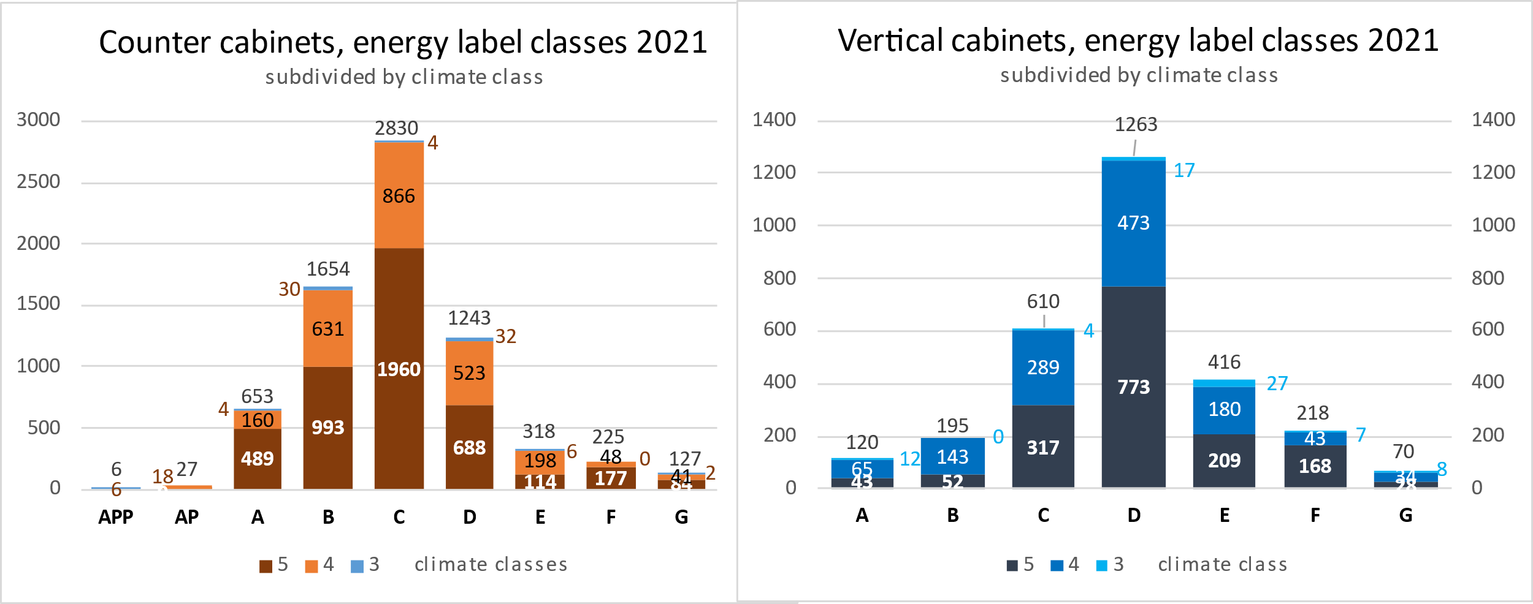

*Figure 8: Energy label classes for counter and vertical cabinets.*

The EPREL data suggests that the current class limits are still ambitious, and the adjustment could focus on progressively eliminating lowest classes (G, F, E) and setting up bands A to D to incentivise improvement, in conformity with the 2017 Energy Label Regulation. (Note that current and proposed EEI values cannot be directly compared due to changes also in the reference line M and N values.)

Proposed revision of the ecodesign limit takes account of apparent stagnation or even backsliding of the market in energy efficiency terms, as well as the economic downturn of the hospitality sector from COVID and other reasons. Proposed thresholds remove around 7 % of the poorest performing models in the first Tier, with a second Tier taking effect in expectation of further market recovery. A more ambitious third Tier will be introduced two years later, in total raising efficiency by almost 30 % with respect to today and eliminating in total about 40 % of models. However, the timing of this third Tier together with the cost implications will have to be discussed.

Professional refrigeration has been a focus of EU market surveillance in recent years through EU co-operation (EEPLIANT2) and national efforts particularly in Scandinavian countries - such efforts to ensure a fair competitive market will remain important.

In the proposal, there are a handful of appliances already in energy label class A, which requires some explanation. The framework regulation says that the Commission “shall ensure that no products are expected to fall into energy class A at the moment of the introduction of the label and the estimated time within which a majority of models falls into that class is at least 10 years later”. The latter criterion is well and truly met due to the economic realities of the sector, but not the former criterion. According to EPREL data, there are few out of 9974 models in the A class category with EEI below 30 in the proposed scheme. This represents <0.5 % of EPREL models and all are small frozen cabinets (110 to 260 litres). As premium quality and so relatively high-priced models, these would account for a vanishingly small proportion of the EU market. The proposed label thresholds are carefully designed to encourage (or at least not dissuade) upward movement. If A class is to be empty, then the EEI threshold must move to 16 — a further cut in energy consumption of almost 50% from the current threshold. If the G/F/E thresholds are moved up to keep step sizes even then the majority of the market would be (worse than) G class, slashing consumer choice at Tier 1 MEPS and making a movement to Tier 2 and Tier 3 difficult to rationalise[38]. The proposal to allow a few products in class A is therefore made.

EPREL data shows that the distribution of label classes for all heavy-duty cabinets is extremely similar to that for standard duty cabinets, with heavy duty cabinets competing alongside or beating the very best standard duty types. Thus, available evidence confirms that the concessional EEI (currently 115 instead of 85 for the other types) should be removed.

As regards the exclusions for cabinets in Article 1(1), review and consultation on each of these confirms that the original reasons for exclusion remain valid. In most cases this is due to extremely low market share with sales numbers too small to warrant the development of standards and introduce a regulation (*proportionality* criterion, see also eligibility criteria in Art. 15.2). Change is recommended only for ‘static air cabinets’ (those without an internal air circulation fan) which should be considered for future addition under household refrigerator regulations. The review study gives a full overview.

The latest GWP-values of refrigerants can be found in the Annex of the 2022 Proposal for a new F-gas regulation[39]. The latest general GWP-values can be found in Commission Delegated Regulation (EU) 2020/1044[40]. Having said that, the Commission leaves the rulemaking of F-gases to the horizontal legislation, but possibly extra information on the GWP-used can be given on the energy label or in the EPREL database, accessible through the QR code on the label, to raise awareness.

The verification tolerance the measured volume <3 % and for the rated energy consumption it is <10 % for refrigerating cabinets. This is in line with verification tolerances for the 2019 Ecodesign regulation of household refrigerators and direct-sales refrigeration cabinets[41].

## Blast cabinets

Blast cabinets are only subject to information requirements in the current ecodesign regulation, but an assessment of the appropriateness of introducing ecodesign requirements for these products is included in the review clause. The review study found supporting evidence and technical feasibility to now include blast cabinets in the scope for efficiency requirements. Their electricity consumption is significant, about 5 TWh/a (approximately half of the professional cabinets currently in the scope) and the information requirements that are currently required for this product group, as well as the newly available standards, give enough input for a correct energy and performance metric.

Based on comprehensive research of data received by stakeholders, a proposal was put forward in the first interim report and subsequently the second stakeholder meeting of a maximum energy consumption of 0.095 kWh/cycle/kg for chilling, and 0.31 kWh/cycle/kg for freezing, where multi-use cabinets have to meet both requirements.

After this initial proposal new (sales-weighted) data was received and analysed (see figures below), which indicated that approximately 50 % of the sold appliances would not meet the proposed freezing threshold. The proposal has therefore been adapted to a 2-Tier approach, with more lenient freezing thresholds. In a first Tier, the maximum energy consumption in kWh per kg of foodstuff per cycle is 0.120 and 0.60 for chilling and freezing respectively, and after two years the second Tier introduces 0.095 and 0.40 for chilling and freezing respectively. This will result in approximately 40 % of appliances not meeting one or both thresholds.

*Figure 9: Chill cycle energy consumption kWh/cycle/kg as declared (sales weighted).*

*Figure 10: Freeze cycle energy consumption kWh/cycle/kg as declared (sales weighted).*

As regards the questions from Phase 1.1, it is concluded that blast cabinets with a remote condensing unit are not part of the scope, and there is no measurement/testing method available for the energy performance of such products.

## Scientific and healthcare refrigerated storage cabinets

The proposed sub-categories of scientific and healthcare refrigerated storage cabinets are:

1. Scientific and healthcare refrigerators (storage temperature range -2 ºC to +20 ºC) including drug refrigerators for pharmacies and medical facilities (storage temperature range +2 ºC to +8 ºC).
2. Scientific and healthcare freezers (storage temperature range -60 ºC to -3 ºC).
3. Ultra-low temperature (ULT) freezers (storage temperature range -90 ºC to -40 ºC).
4. Refrigerators for storage of blood (+2 ºC to +6 ºC).
5. Freezers for storage of plasma (<-27 ºC).

These are used for storage of items including chemicals and reagents, vaccines, drugs, medical, blood and tissue samples with cabinet prices ranging from €2 500 to €10 000 a piece.

Note: Cryogenic freezers (storage temperature range -155 ºC to -125 ºC) are not proposed for further consideration as they are highly specialised technologies sold in relatively small numbers.

Assuming the EU to make up around 20 % of the global market for science and healthcare[42], the sales of laboratory refrigerators and freezers can be estimated at around 150 000 units and the stock is 0.2 million Ultra Low Temperature (ULT) units and 1 million laboratory grade units. Electricity use is estimated at around 3 TWh/a for the laboratory/scientific sector alone; an estimate for healthcare delivery (hospitals, pharmacies, doctor surgeries) is yet to be made but could be higher than that for scientific.

The sector is growing at rates an order of magnitude higher than parallel appliance groups (also some others are contracting), as a result of science and manufacturing investment driven by the global pandemic. One national industry association that gathered unit sales statistics accounting for 13 manufacturers of ULT cabinets found 52 % growth 2019 to 2020 and 20 % growth 2020 to 2021. A recent University of Copenhagen report stated that 'even brand-new eco-friendly ULT freezers consume between half and one-and-a-half times as much power as a 4-person household in Denmark’[43] – being between 3 500 and 8 000 kWh per year.

Manufacturers and other stakeholders of scientific and healthcare refrigerated storage cabinets have shown enthusiasm for energy labelling and given practical help to gather the necessary evidence and momentum to support an initiative that is globally coordinated. Scientific lab staff tend to be highly interested in the energy and environmental performance of equipment they buy and use, and are motivated to reduce impact of their activities. Academic and scientific users are increasingly seeking to reduce their carbon impact. Manufacturers assert substantial progress on energy efficiency in recent years; anecdotal evidence suggests 15 % to 30 % improvement in efficiency is not uncommon but progress has been patchy and non-transparent due to various poorly explained and non-comparable ways to assess energy performance.

Many factors combine to suggest that this sector is both well capable of assimilating ecodesign and energy labelling measures and would be welcoming of them due to the need of its multiple benefits. This market:

* Is growing and successful.
* Has technically able suppliers used to working to exacting standards.
* Has scope to improve energy efficiency.
* Shows wide disparity of energy performance for equipment with similar functionality.
* Lacks comparability of performance across different suppliers and countries.
* Has buyers interested in and motivated by energy efficiency and environmental impacts.
* Has buyers with the budget flexibility to choose better performance.
* Has buyers and users demonstrably keen to make behavioural and procurement changes to reduce environmental impact of their activities.

Evidence so far suggests that this market appears highly appropriate for the introduction of energy labelling and a proposal for energy labelling is presented. MEPS are not proposed as full flexibility to address specific purposes is needed, and the buyers are sufficiently technically aware and motivated to choose the most energy efficient appliance consistent with their specific need.

## Condensing units

Based on comprehensive market research, the review study has put together energy efficiency data for condensing units on the market in 2021, subdivided in the currently 2 temperature classes (Medium Temperature and Low Temperature: MT and LT), with each 4 size classes. Efficiency numbers for the two lower size classes are given in COP (Coefficient of Performance) and for the two higher classes in SEPR (Seasonal Energy Performance Ratio). The scatter plot below illustrates the outcome for medium temperature units in the size 5 to 20 kW.



*Figure 11: Representative SEPR values of medium temperature (MT) condensing units in the range from 5 – 20 kW cooling.*

Main conclusions from the analysis are that most COPs and SEPRs are much better than the MEPS-values over the whole range of cooling capacities. But no improvements could be observed in the BAT-values since the preparatory study of 2015, which refers to data from 2012. The totality of the values shows a typical broad distribution for products beyond the regulated MEPS level, which indicates a clear potential for improvement. As a result, adaptation of MEPS towards more ambitious levels seems the way forward. Given that the units are purchased not always by refrigeration experts that would know how to interpret the technical specifications (in hospitality, supermarkets, etc.[44]), and also given that access to subsidies is often linked to top energy label classes (B, C), introducing an A-G efficiency labelling scheme seems the way forward to foster BAT development.

Therefore, a labelling scheme is proposed, with still 2 temperature classes but only 2 LT size classes (0.1-2 kW and 2-20 kW) and only 2 MT size classes (0.2-5 kW and 5-50 kW). This simplification can be realised by using slant class-limit lines, using the size (=cooling capacity C in kW) as a parameter. The graph for the MT 5-50kW class gives an illustration (see figure 12 below), where — as appropriate following the 2017 Energy Label Regulation, the A-class is empty.

*Figure 12: Calculation for an A-G efficiency scheme for low temperature (LT) condensing units of the cooling range from 5 - 50 kW.*

For ecodesign, a 2-Tier approach is proposed where, after a one-year adaption period from entry into force of the legislation, the upper G-class limit (=lower F-class limit) sets the firstminimum ecodesign Tier. In a second Tier, two years later, the upper F-class limit would set the minimum ecodesign limit.

Note that the 10 % bonus for refrigerants with GWP <150 no longer applies as this is set already as a maximum by the F-gas regulation[45] starting 1 January 2022.

As regards the questions from Phase 1.1:

* Condensing units with lower and higher rated cooling capacity than in the current scope (<0.2 kW and >50 kW at medium temperature MT and <0.1 kW and >20 kW at low temperature) were also found by this study, but were found to have a very low market share. Thus, extension of the scope in that direction is not proposed.
* Condensing units including an evaporator or having a factory determined evaporator cannot be considered as condensing unit, but process chillers or packaged refrigeration units. Both of these cannot be put under the rules and standards for condensing unit, but would be placed under process chiller rules or air cooler rules.
* Compressor racks and packs are not condensing units, and cannot be put under the rules and standards for condensing units. As the condenser is missing, the rating conditions do not match the technology. As most racks have added functionality, standard rating is not meaningful at all.
* Water-cooled condensing units are produced in small numbers and are thus a small part of the condensing unit market. Thus, the energy saving impact is not high. Additionally, the rating standard is not feasible for the targets of the Regulation. Thus, there is no market data basis for evaluation of the performance level and improvement potential.

## Process chillers

Like with condensing units, data were retrieved from manufacturer’s documentation, especially following the second stakeholder meeting (January 2022), where a preliminary, ambitious proposal was presented. Following those most recent data, the proposal for air-cooled MT chillers was made less stringent and reduced to a SEPR level of 3.5 for size 100-300 kW (instead of 3.6) and 3.8 for larger sizes (instead of 4.0). The main reason is that at the previous SEPR values the most screw compressor technology would risk being phased out or — at great expense — would require very large heat exchangers. The alternative would then be reciprocating compressors, which have high maintenance costs. The latter would be damaging especially for SMEs.

The figure below page shows a cloud diagram of the air-cooled MT units by a few manufacturers with only scroll and screw compressor chillers at a low GWP (<150), which — following the F-gas regulation — would be the only GWP level admitted long-term. Reciprocating compressors with higher efficiency values are not included.

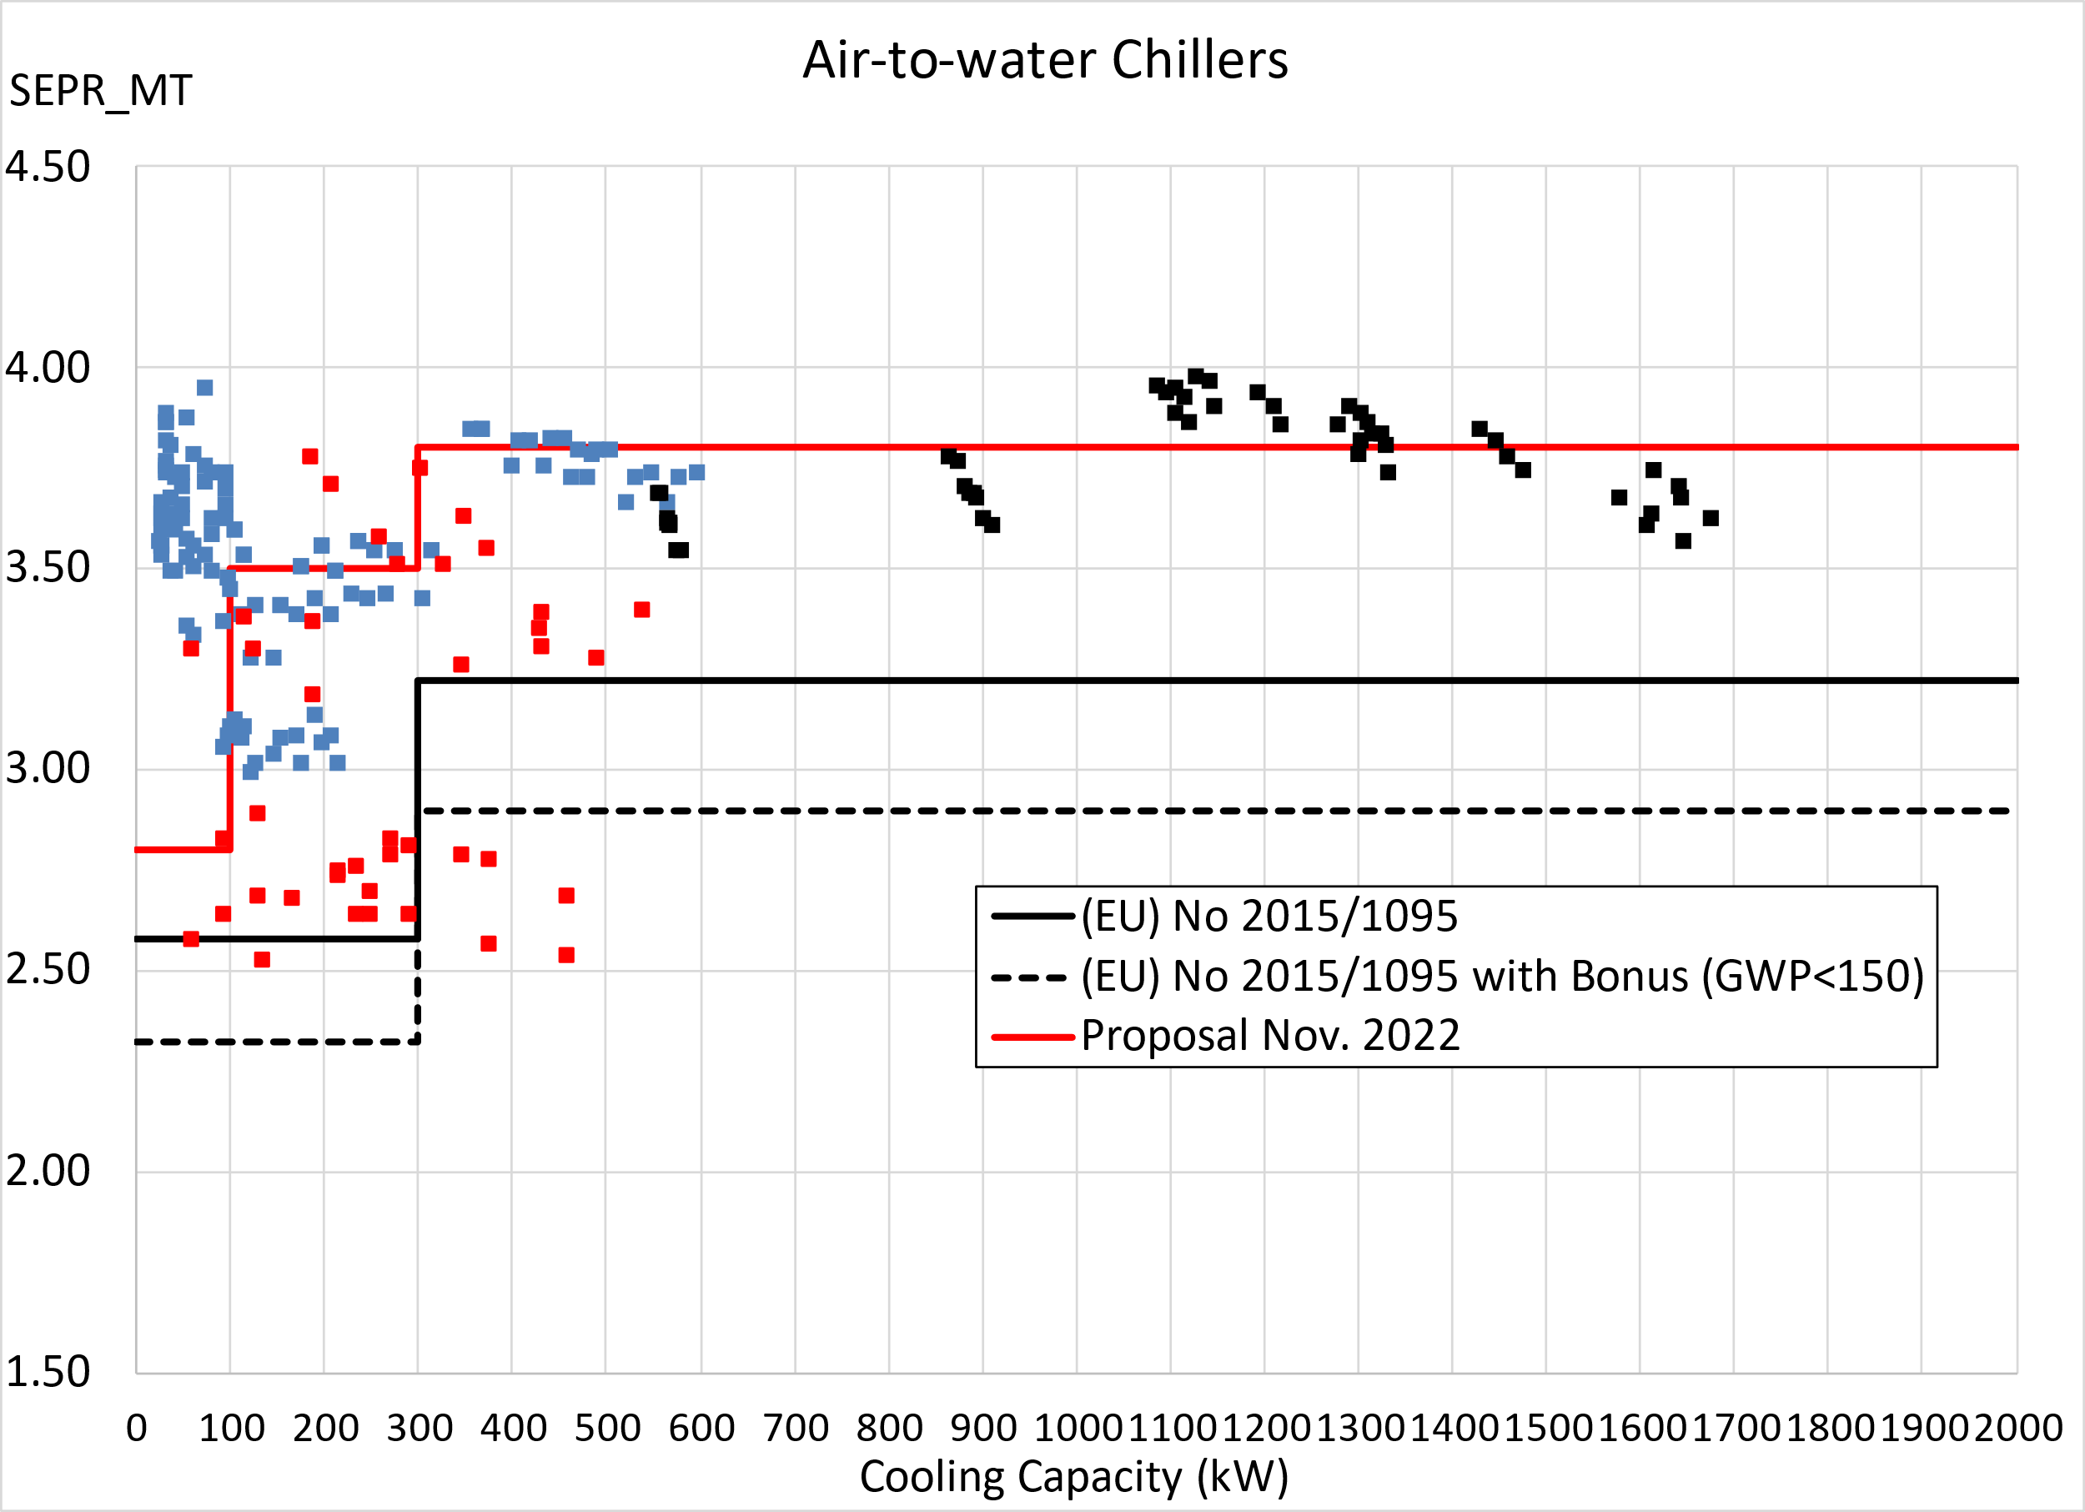

*Figure 13: Retrieved SEPR data from 3 manufacturers, for low-GWP screw and scroll MT air-cooled process chillers and minimum limits for air-cooled MT process chillers from 2015 and currently proposed minimum limits.*

The diagram shows best available SEPR-values at a level of just below 4.2. The new limits are 18 % higher than the current 2018 limits for this category, which is ambitious, probably eliminating about 40 % of existing low-GWP models. To give enough time, a single tier in 2027 is considered, following entry into force in 2024. This is also in line with the developments foreseen in the F-gas regulation, where 2027 is a critical milestone.

As regards the impact on industry and consumers, expert interviews show that a main market driver for this product is the energy cost of the consumer and thus the efficiency of the product. Furthermore, the main manufacturers in this market are large companies, with SMEs found in customising and installing the standard units. Setting the “ErP 2027-limit” at an ambitious level will thus help not only environmentally, but also commercially.

The limits for the air-cooled MT chillers category were the most critical. The new limits, also in the range of a 14-18 % increase compared to current limits, for water-cooled MT chillers nor for the LT chillers led to comments.

As regards the questions from Phase 1.1, the study team conducted expert interviews and found that including process chillers with evaporative cooling or absorption technology in the existing categories would not give a level playing field. And setting up separate categories for these niche markets would not be proportional. Hence it is not proposed to extend the scope to these technologies.

CO2-based chiller systems do exist and should be included in the scope. As regards systems with high viscosity liquids more information is needed from stakeholders on the technical details to decide on definition and scope.

## Product proposed to be excluded

For the walk-in cold rooms (WICRs) the issue has been extensively studied. In terms of energy consumption, it could be an interesting addition to the scope. There are new EN standards covering (separately) performance of the insulated envelope and the packaged refrigeration units, though no overall performance metric. A US DOE rule covers walk-in cold rooms but mainly for specific components plus a complex overall performance metric, but this precedent could help inform an EU approach. The main challenge is that walk-in cold rooms are mostly built on-site with components (panels, doors, refrigeration units) from different suppliers/OEMs with details of design/sizing and quality of assembly having an overriding impact on eventual energy efficiency. This also makes market surveillance challenging. Furthermore, the companies building the units are in majority SMEs operating in a very competitive business environment. For very similar reasons to their exclusion a decade ago from the current ecodesign regulation, it is concluded that conditions are not yet in place to regulate walk-in cold rooms under ecodesign, despite efforts by the industry to develop test standards. However, with coordination to establish an overall performance assessment method combined with a code of practice for design and assembly, major improvement of efficiency would be a practical likelihood.

For ice makers most information and standards are from countries outside the EU. In Europe, Switzerland has produced most information at policy level. It shows that the energy use is not insignificant[46], but the preparation of measures in terms of measurement standards and co-operation of stakeholders require a considerable effort. It is proposed to include ice makers in the review clause.

Refrigerator-freezers are rare in the professional appliances sector and no EN/ISO test standards cover them and would need to be developed to include these products. Overall, with a single exception, there was no support from stakeholders nor compelling evidence to include them in the scope.

Static refrigerated containers are a very small EU market of a few hundred units a year and preparing measures would not be proportional.

## Preliminary impact assessment

Overall, it can be expected that the proposed measures will lead to an extra energy saving (compared to BAU) of about 15-18 % over the 12 years after entry into force. The GHG abatement will be in the same order of magnitude. More specific indications will be given in the final review study report.

4. Budgetary implications

The legal format of Commission (Delegated) Regulations does not require transpositions into national legislation, saving administrative costs at Member State level. Development, operation, maintenance and IT security of the EPREL database at EU level as well as EU support for the enforcement by the national MSA's and miscellaneous reporting activities will require resources.

5. Additional information

Note that this review concerns secondary acts, which follow the subsidiarity and proportionality report in the primary act. A specific discussion of these two aspects is not required.

The proposed Regulation concerns an EEA matter and should therefore extend to the European Economic Area.

1. [Commission Regulation (EU) 2015/1095 of 5 May 2015 implementing Directive 2009/125/EC of the European Parliament and of the Council with regard to ecodesign requirements for professional refrigerated storage cabinets, blast cabinets, condensing units and process chillers, OJ L 177, 8.7.2015, p. 19–51](https://eur-lex.europa.eu/legal-content/EN/TXT/?uri=CELEX%3A32015R1095)
2. [Commission Delegated Regulation (EU) 2015/1094 of 5 May 2015 supplementing Directive 2010/30/EU of the European Parliament and of the Council with regard to the energy labelling of professional refrigerated storage cabinets, OJ L 177, 8.7.2015, p. 2–18](https://eur-lex.europa.eu/legal-content/EN/TXT/?uri=uriserv%3AOJ.L_.2015.177.01.0002.01.ENG)
3. [The European Green Deal, COM(2019) 640 final.](https://eur-lex.europa.eu/legal-content/EN/TXT/?uri=COM%3A2019%3A640%3AFIN)
4. [Transforming our world: the 2030 Agenda for Sustainable Development.](https://sdgs.un.org/2030agenda)
5. [Stepping up Europe’s 2030 climate ambition. Investing in a climate-neutral future for the benefit of our people, COM/2020/562 final](https://eur-lex.europa.eu/legal-content/EN/TXT/?uri=CELEX%3A52020DC0562).
6. [‘Fit for 55’: delivering the EU’s 2030 Climate Target on the way to climate neutrality, COM(2021) 550 final.](https://eur-lex.europa.eu/legal-content/EN/TXT/?uri=CELEX%3A52021DC0550)
7. [Circular Economy Action Plan for a more competitive Europe, COM(2020) 98](https://eur-lex.europa.eu/legal-content/EN/TXT/?uri=COM:2020:98:FIN&WT.mc_id=Twitter).
8. [Ecodesign and Energy Labelling Working Plan 2022-2024, C(2022) 2026.](https://energy.ec.europa.eu/ecodesign-and-energy-labelling-working-plan-2022-2024_en)
9. [REPowerEU Plan, COM(2022) 230 final](https://eur-lex.europa.eu/legal-content/EN/TXT/?uri=COM%3A2022%3A230%3AFIN&qid=1653033742483).
10. [Directive 2009/125/EC of the European Parliament and of the Council of 21 October 2009 establishing a framework for the setting of ecodesign requirements for energy-related products. OJ L 285, 31.10.2009, p.10](https://eur-lex.europa.eu/legal-content/EN/ALL/?uri=celex%3A32009L0125).
11. [Regulation (EU) 2017/1369 of the European Parliament and of the Council of 4 July 2017 setting a framework for energy labelling and repealing Directive 2010/30/EU. OJ L 198, 28.7.2017, p. 1–23](https://eur-lex.europa.eu/eli/reg/2017/1369/oj).
12. [Special Eurobarometer 492. “Europeans’ attitudes on energy policy report. European Commission September 2019.](https://data.europa.eu/data/datasets/s2238_91_4_492_eng?locale=en)
13. [Impacts of the EU’s Ecodesign and Energy/Tyre Labelling Legislation on Third Jurisdictions (Paul Waide et al. April 2014).](https://ec.europa.eu/energy/sites/ener/files/documents/201404_ieel_third_jurisdictions.pdf)
14. [Commission Regulation (EU) 2016/2281 of 30 November 2016 implementing Directive 2009/125/EC of the European Parliament and of the Council establishing a framework for the setting of ecodesign requirements for energy-related products, with regard to ecodesign requirements for air heating products, cooling products, high temperature process chillers and fan coil units. OJ L 346, 20.12.2016, p. 1–50](https://eur-lex.europa.eu/legal-content/EN/TXT/?uri=uriserv%3AOJ.L_.2016.346.01.0001.01.ENG).
15. Note that this 2030 projection is based on data and trends that are pre-covid, pre-energy price soaring and pre-Ukraine conflict. Depending on the longer-term impact of these crises the outcome may be very different, either lower because acquisitions are postponed for lack of funds, or higher because the energy costs prompt an accelerated replacement of less efficient appliances.
16. According to CBS the NL electricity consumption fluctuated between 110 and 115 TWh/a between 2010 and 2019. It also exceeds the electricity consumed by other ecodesign regulated refrigeration appliances for household refrigerating appliances or refrigerating appliances with a direct sales function.
17. At PRIMES REFERENCE 2000 rates for the tertiary and industry sector.
18. Eurostat PRODCOM Exports, Imports, Production, Apparent Consumption of Refrigerating & Freezing Equipment statistics EU27, 2018, in quantity and value (extract VHK 19.3.2021).
19. <https://ec.europa.eu/growth/tools-databases/mandates/index.cfm?fuseaction=search.detail&id=534>
20. Blast chillers and freezers cabinets for professional use - Classification, requirements and test conditions.
21. Blast chillers and freezers cabinets for professional use. Classification, requirements and test conditions.
22. Refrigerated storage cabinets and counters for professional use. Performance and energy consumption. Replaces EN 16825:2016+A1:2019
23. Air conditioners, liquid chilling packages and heat pumps, with electrically driven compressors, for space heating and cooling, commercial and process cooling — Testing and rating at part load conditions and calculation of seasonal performance (CEN/TC 113/WG 7).
24. Condensing units for refrigeration - Rating conditions, tolerances and presentation of manufacturer's performance data.
25. Refrigerators and freezers for the medical sector - Definitions, requirements, testing. Published May 2022.
26. Series 1 freight containers — Specification and testing — Part 2: Thermal containers.
27. Series 1 freight containers — Classification, dimensions and ratings.
28. Ice makers for commercial use - Classification, requirements and test conditions.
29. Method of Testing Automatic Ice Makers.
30. Performance rating of automatic commercial ice-makers.
31. Contractor is a consortium led by VITO, also contract manager for this contract. Technical project lead is VHK, in collaboration with experts from Tait Consulting and the Wuppertal Institute for Climate, Environment and Energy. Review study for EC, DG GROW.
32. And some specific issues regarding for instance standardisation, as identified by the Commission.
33. EN 16825 versus the new EN ISO 22041+A1:2019.
34. EN 17032:2018/A1:2019 versus the new EN ISO 22042:2021.
35. Or variations of existing testing standards, such as EN 16825 or EN 22041.
36. EN 13215:2016+A1:2020 Condensing units for refrigeration - Rating conditions, tolerances and presentation of manufacturer's performance data.
37. WG=Working Group, TC=Technical Committee. CEN and Cenelec are European standardisation organisations.
38. Assuming that MEPS remain aligned with label classes – whilst not unprecedented, enforcement is harder and consumer understanding would be stretched.
39. [COM(2022) 150 final, Proposal for a Regulation of the European Parliament and of the Council on fluorinated greenhouse gases, amending Directive (EU) 2019/1937 and repealing Regulation (EU) No 517/2014, April 2022 (ANNEX I)](https://eur-lex.europa.eu/legal-content/EN/TXT/HTML/?uri=CELEX:52022PC0150).
40. [COMMISSION DELEGATED REGULATION (EU) 2020/1044 of 8 May 2020 supplementing Regulation (EU) 2018/1999 of the European Parliament and of the Council with regard to values for global warming potentials and the inventory guidelines and with regard to the Union inventory system and repealing Commission Delegated Regulation (EU) No 666/2014, OJ L 230, 17.7.2020, p. 1–6](https://eur-lex.europa.eu/legal-content/EN/TXT/?uri=CELEX%3A32020R1044)
41. [Regulation (EU) 2019/2019 on ecodesign requirements for (household) refrigerating appliances.](https://eur-lex.europa.eu/legal-content/EN/TXT/?uri=uriserv:OJ.L_.2019.315.01.0187.01.ENG)

    [Delegated Regulation (EU) 2019/2016 on energy labelling of refrigerating appliances](https://eur-lex.europa.eu/legal-content/EN/AUTO/?uri=celex:32019R2016)

    [Regulation (EU) 2019/2024 on ecodesign requirements for refrigerating appliances with a direct sales function](https://eur-lex.europa.eu/legal-content/EN/AUTO/?uri=celex:32019R2024https://eur-lex.europa.eu/legal-content/EN/AUTO/?uri=celex:32019R2024)

    [Delegated Regulation (EU) 2019/2018 on energy labelling of refrigerating appliances with a direct sales function](https://eur-lex.europa.eu/legal-content/EN/AUTO/?uri=celex:32019R2018)
42. The EU accounts for around 23 % of the global market value for pharmaceuticals, from EFPIA data, available from: <https://efpia.eu/media/554521/efpia_pharmafigures_2020_web.pdf>.
43. Plug load test for ULT Freezers: 20-22 % lower energy consumption at -70 ºC compared to -80 ºC, University of Copenhagen, <https://baeredygtighed2030.ku.dk/pdf/freezer_test.pdf/>.
44. This is also the reason why there are energy labels for the professional refrigeration cabinets and direct sales refrigeration appliances.
45. [Regulation (EU) No 517/2014 of the European Parliament and of the Council of 16 April 2014 on fluorinated greenhouse gases and repealing Regulation (EC) No 842/2006. OJ L 150, 20.5.2014, p. 195–230.](https://eur-lex.europa.eu/legal-content/EN/TXT/?uri=celex%3A32014R0517)
46. Rough estimate on the basis of data from [Swiss BFE Study 2021](https://pubdb.bfe.admin.ch/de/publication/download/10718): 1.5 million EU stock, 80 kg ice/day, 365 days/year, 60% occupancy rate, 0.13 kWh/kg ice gives 3.4 TWh/year. Saving potential from expert interviews about 20 % gives 0.7 TWh/year.